Zemax Tutorial
Simulate a simple scanning system consisting of a scan lens, a tube lens, and an objective.

Example 1: Build the system using paraxial lenses (perfect lenses).
- Open a new file from the tab File -> New.

- Create collimated laser beam with 2-mm diameter and scanning angle of 5 degrees in the window of System Explorer.
  - Aperture type: Entrance Pupil Diameter
  - Aperture Value: 2mm
  - Setting field type: Fields -> Settings -> Type: Angle (degree)
  - Add two more fields: One has the scanning angle of +5 degrees and the other one has -5 degrees. Click on Add Field; enable the field by checking Enable; Set the Y values +5 and -5 degrees, individually.
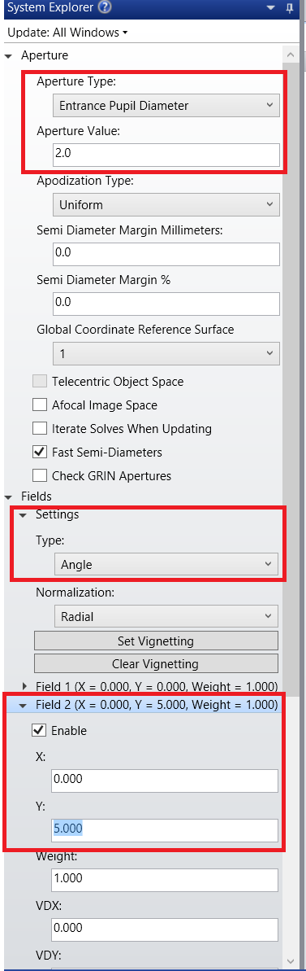
- Set up a scan lens in the table of Lens Data with 50-mm focal length and distance of 50 mm from a field stop.
  - Insert the scan lens after the field STOP: Right click -> Insert Surface After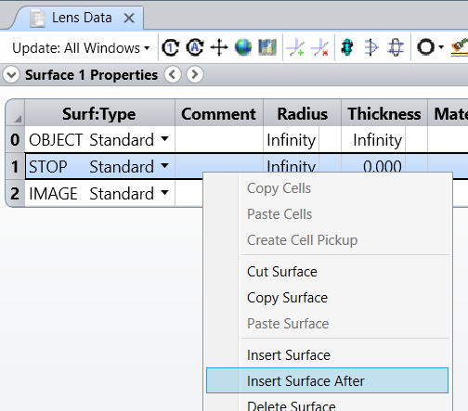
  - Choose Paraxial from the pull-down list under the column of Surf:Type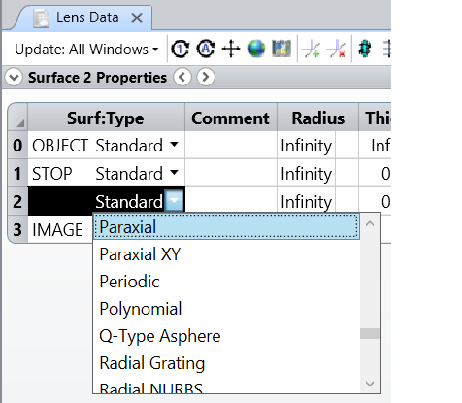
  - Set the Thickness 250 mm and the Focal length 50 mm. Thickness is the distance to the next surface.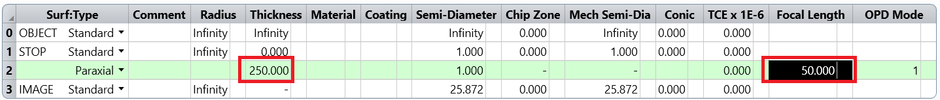
  - Set the Thickness 50 mm for the row 1, so that the distance of the STOP to the scan lens is 50 mm.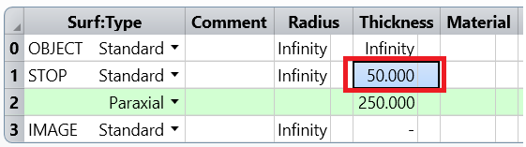

- Set up a tube lens in the table of Lens Data with 200-mm focal length and distance of 200 mm to the objective next to it.
  - Insert the tube lens after the scan lens: Right click -> Insert Surface After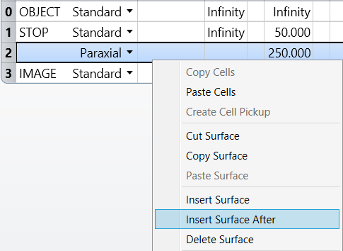
  - Set Surf:Type Paraxial, Thickness 200 mm, Focal Length 200 mm
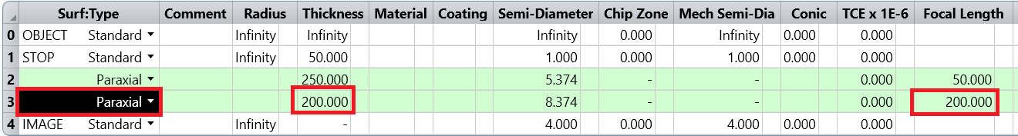

- Set up an objective in the table of Lens Data with 10-mm focal length and 200 mm away from the tube lens.
  - Insert the objective after the tube lens: Right click -> Insert Surface After
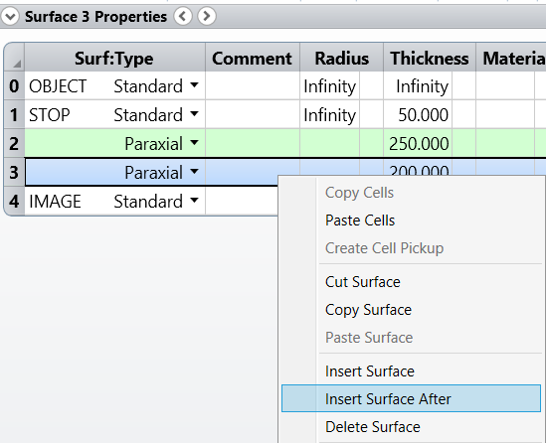
  - Set Surf:Type Paraxial, Thickness 10 mm, Focal Length 10 mm
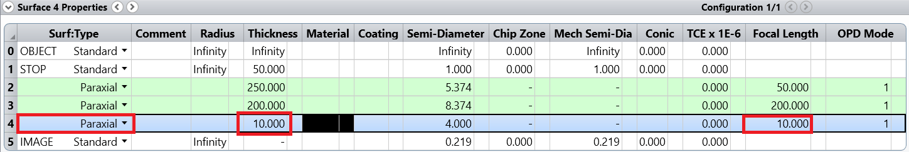

- Check the Layout of the design.
  - Click on the button of Cross-Section.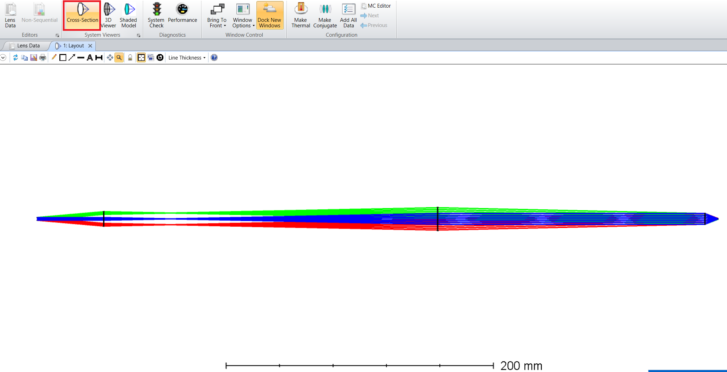
Example 2: Build the system using off-the-shelf lenses and optimize the performance.
The details of the lenses
 | Item number | Diameter (mm) | Focal Length  (mm) | Radius of curvature (mm) | Center Thickness(mm) | Back Focal Length  (mm) | Material
Scan lens | LA1255 | 25.0 | 50.0 | 25.8 | 5.3 | 46.6 | N-BK7
Tube lens | LA1253 | 25.0 | 200.0 | 103 | 2.80 | 198.1 | N-BK7
Objective | Paraxial lens |  | 10mm

- Open a new file from the tab File -> New.

- Create collimated laser beam with 2-mm diameter and scanning angle of 5 degrees in the window of System Explorer.
  - Aperture type: Entrance Pupil Diameter
  - Aperture Value: 2mm
  - Setting field type: Fields -> Settings -> Type: Angle (degree)
  - Add two more fields: Click on Add Field; enable the field by checking Enable; Set the Y value +/- 5 (degree)

- Set up the scan lens, LA1255, in the table of Lens Data.
  - Set Thickness of 46.6 mm for the STOP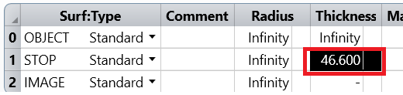
  - Insert the scan lens after the field STOP: Right click -> Insert Surface After
  - Set Radius 25.8 mm, Thickness 5.3mm, Material N-BK7 and Semi-Diameter 12.5mm.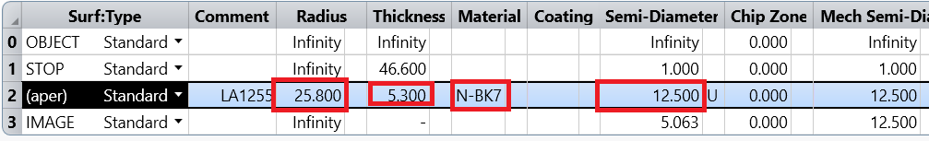
  - Insert the second surface of the lens: Right click -> Insert Surface After
  - Set Radius Infinity, Thickness 250mm, and Semi-Diameter 12.5mm.
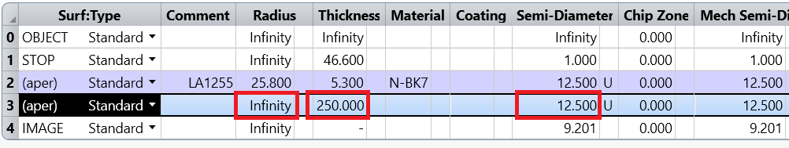

- Set up the tube lens, LA1253, in the table of Lens Data.
  - Insert the tube lens after the scan lens: Right click -> Insert Surface After; Set Radius Infinity, Thickness 2.8mm, Material N-BK7 and Semi-Diameter 12.5mm.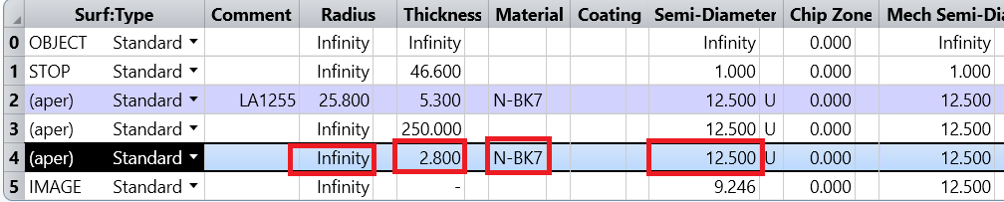
  - Insert the second surface of the tube lens: Right click -> Insert Surface After; Set Radius -103, Thickness 198.1mm, and Semi-Diameter 12.5mm.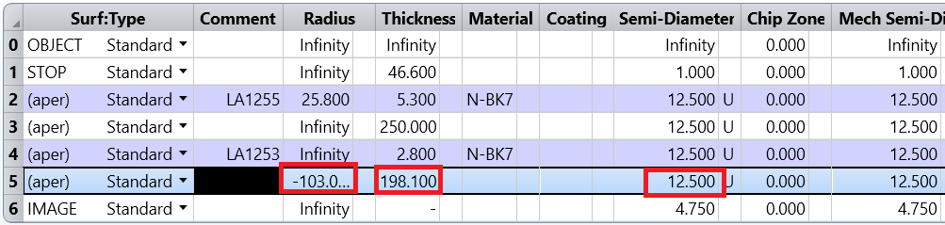
- Set up an (paraxial) objective in the table of Lens Data with 10-mm focal length.
  - Insert the objective after the tube lens: Right click -> Insert Surface After;
  - Set Surf:Type Paraxial, Thickness 10 mm, Focal Length 10 mm
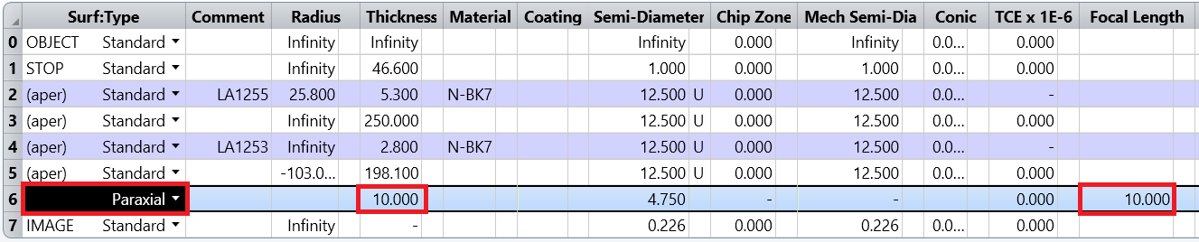

- Check the Layout of the design.
  - Click on the button of Cross-Section.
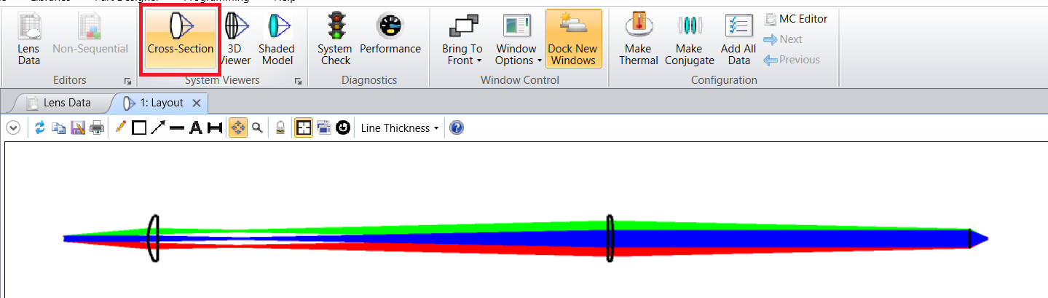
- Check the RMS spot radius at the imaging plane
  - Analysis -> Rays & Spots -> Standard Spot Diagram
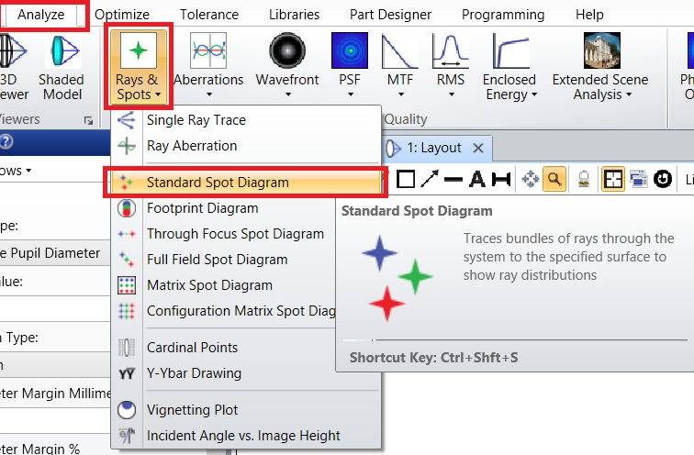
  - The RMS spot radius is 5.4 μm on axis, and about 7.2 μm at the 5° field point.
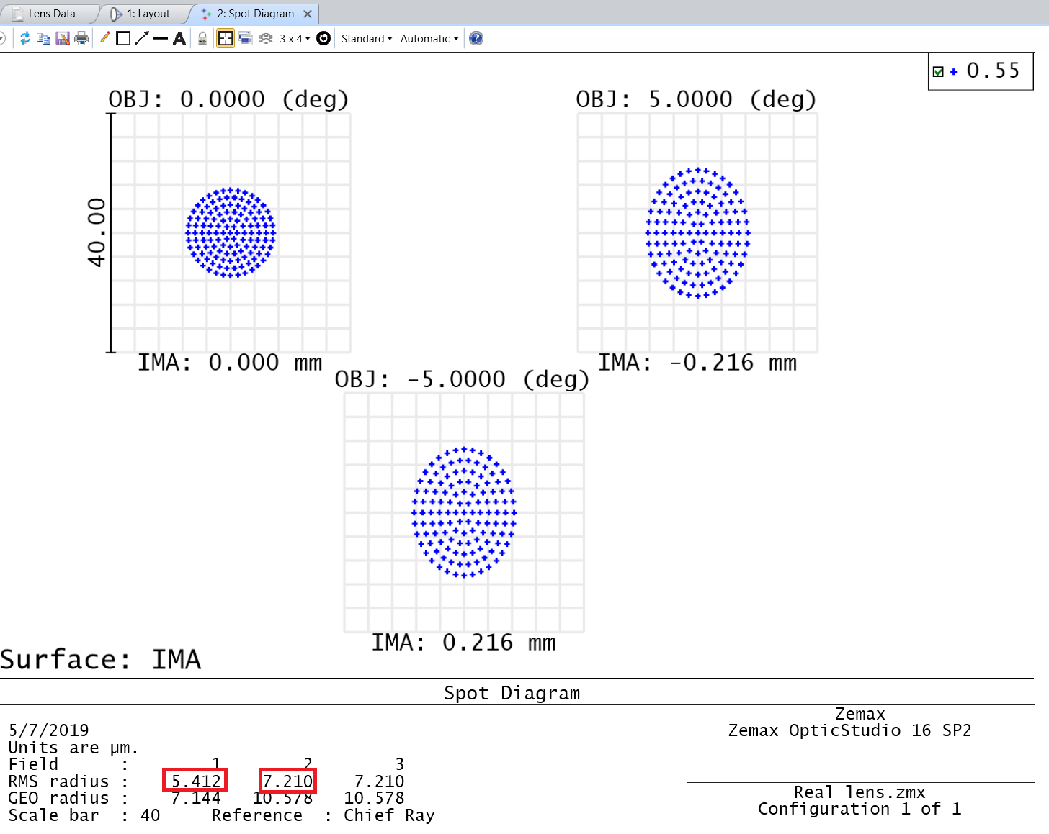

- Setting Variables to optimize the performance of the system
  - Tell Zemax what it may change. Click on the cell to the right of the parameter we want to adjust, and selecting the ‘variable’ solve. Set all of the air space between lenses ‘variable’.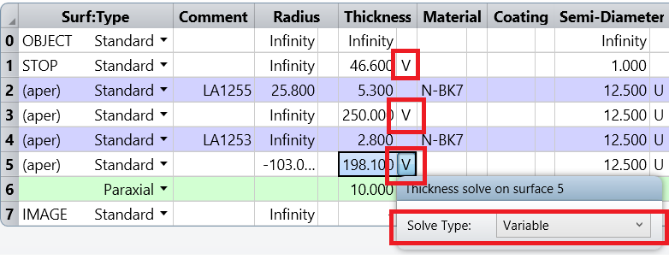
  - The status flag V indicates variables that Zemax may change the values of.

- Defining the Merit Function for the design.
  - In the Optimize tab, click on Optimization Wizard in the Automatic Optimization group
  - This will open the Merit Function Editor. We want the smallest RMS spot radius, choose RMS Spot Radius, relative to the centroid, and press the OK button to close the Optimization Wizard.
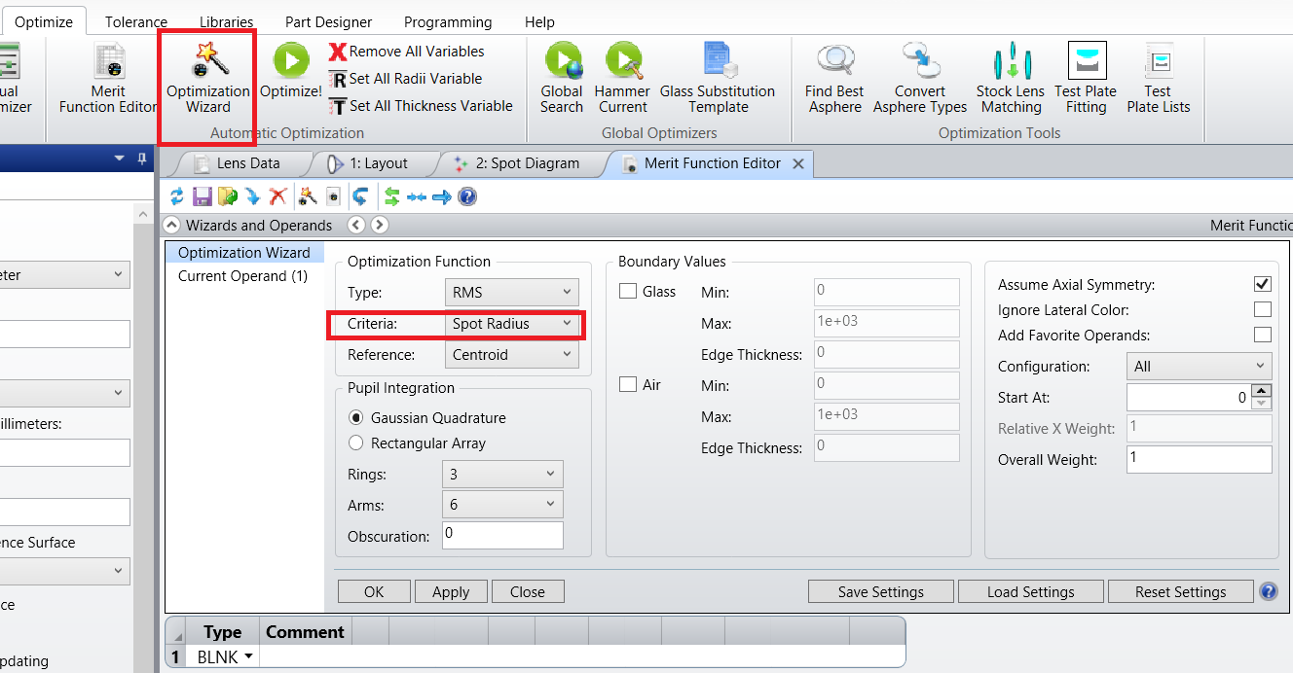
  - Zemax will then write out a merit function.
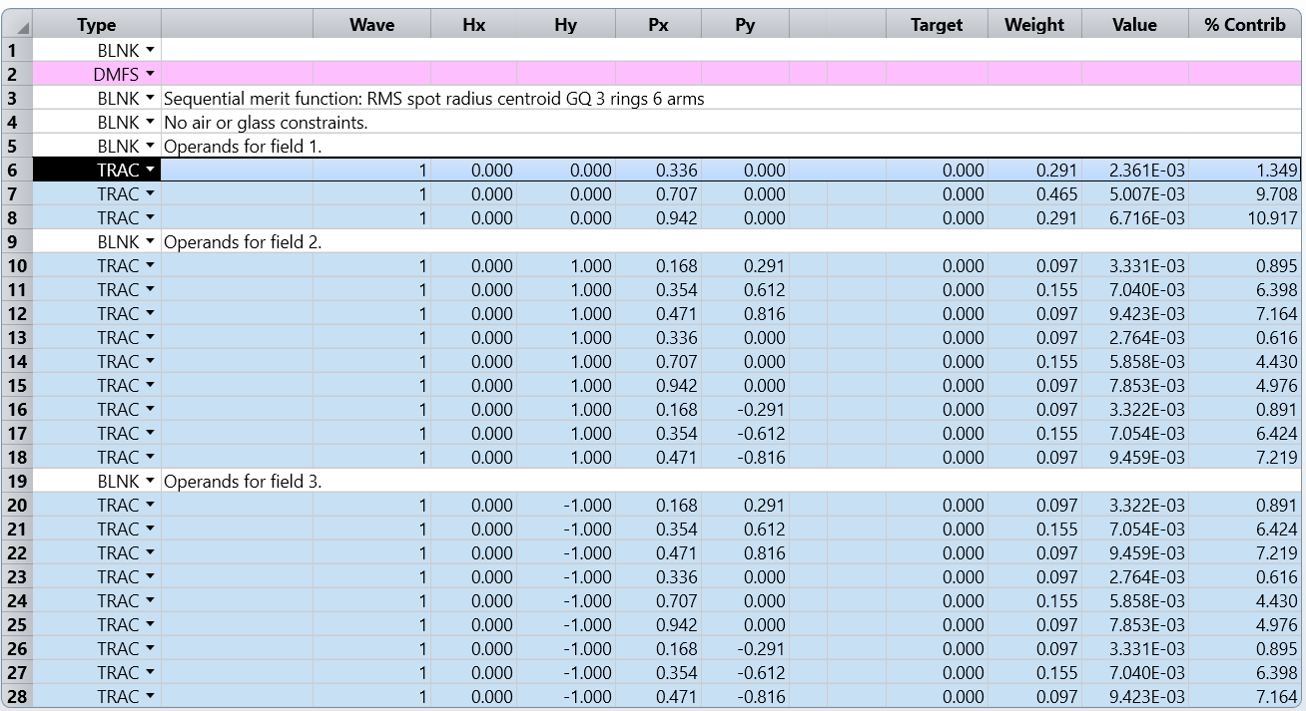
  - “Each row in the Merit Function Editor contains an operand, which computes some value. The TRAC operand, for example, computes the radial point at which a specified ray lands on the image plane, relative to the average of all rays from that field point. Note that each TRAC operand traces a ray defined by its wavelength number, and its (Hx, Hy, Px, Py) normalized coordinates. Different operands will take different arguments, and the names of the arguments are given in the header row of the Editor.
Each operand that computes a value returns that value in the ‘Value’ column of the editor. The operand is also given a target value to achieve, and a weight. The merit function value is then computed as:
$${MF}^{2}=\frac{\sum{{W_{i}\left(V_{i}-T_{i}\right)}^{2}}}{\sum{W_{i}}}$$
where W_{i} is the weight of the ith operand, V_{i} is its computed value and T_{i} is its target value, and the summation is over all the operands in the merit function. As the computed values of the operands move towards their target values, the merit function value approaches zero. Because the difference between the target and actual values of each operand is squared, any deviation from the target value yields an increasingly positive value of the merit function.
Note: The goal of the optimizer is to reduce the merit function to zero, or as close as possible, by adjusting the values of the variable parameters in the Lens Data Editor.”
Reference:
Zemax, LLC Getting Started With OpticStudio 15 “https://customers.zemax.com/ZMXLLC/media/PDFLibrary/Brochures/OpticStudio_GettingStarted.pdf?ext=.pdf”

- Optimizing the Lens
  - Click the Optimize! icon in the Automatic Optimization group, and then press the Start button. Note that the merit function value quickly falls.
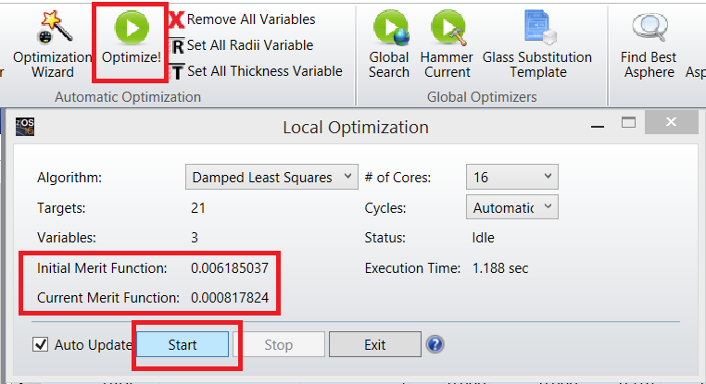

  - The Spot Diagram plot shows the improved performance (double-click it to make it update). The RMS spot radius is now 0.9 μm on axis, and about 0.8 μm at the 5° field point, compared to 5.4 μm and 7.2 μm prior to the optimization. That’s a big improvement!
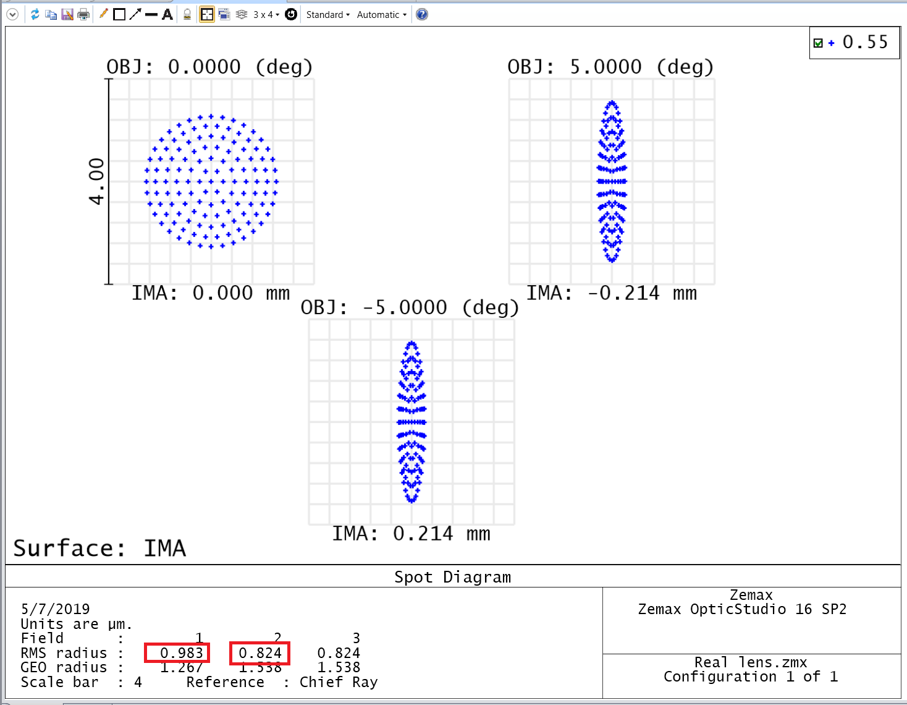
  - However, there is a clear problem, which can be seen in the Layout plot. The distance between the tube lens and the objective is unfeasibly large, ~42,000 mm! We have told Zemax to minimize the RMS spot radius, but have given it no guidance about any constraints it must operate within.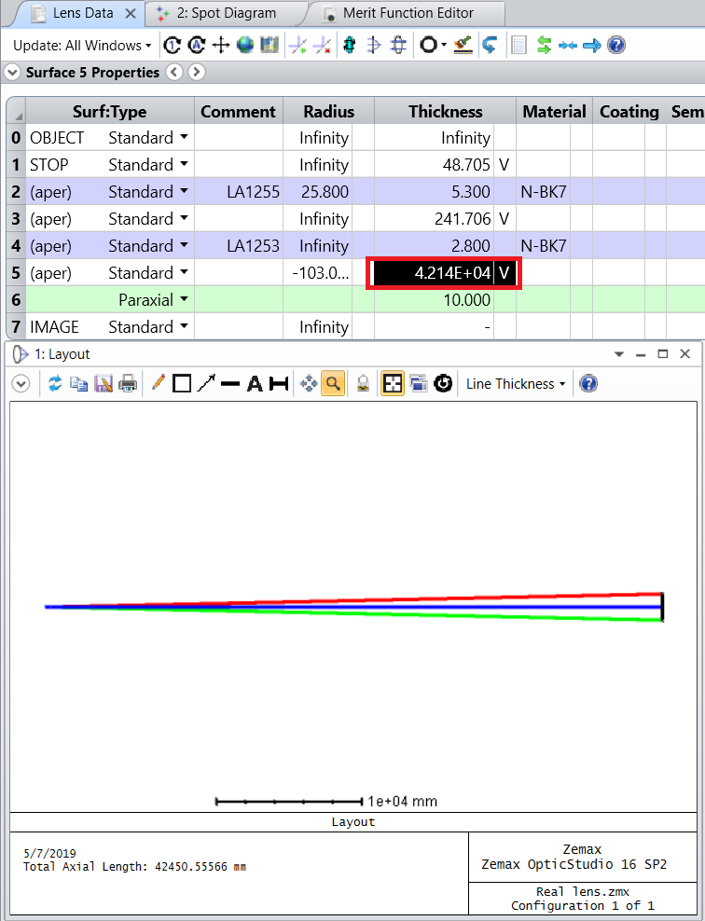

  - Press the F3 button, or click on the Undo icon. This will undo the optimization and restore the previous, un-optimized system. 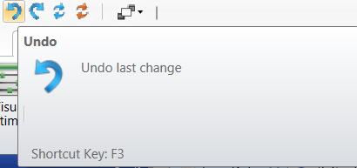

  - Click on the Optimization Wizard again and set up the following changes. These settings require that any surfaces made of air must have thicknesses between 0.5 and 1000 mm, which will prevent lens elements from hitting each other or being unreasonably far away from each other, and is therefore added here for completeness. Click OK to enforce the changes. Press the Optimize! icon again.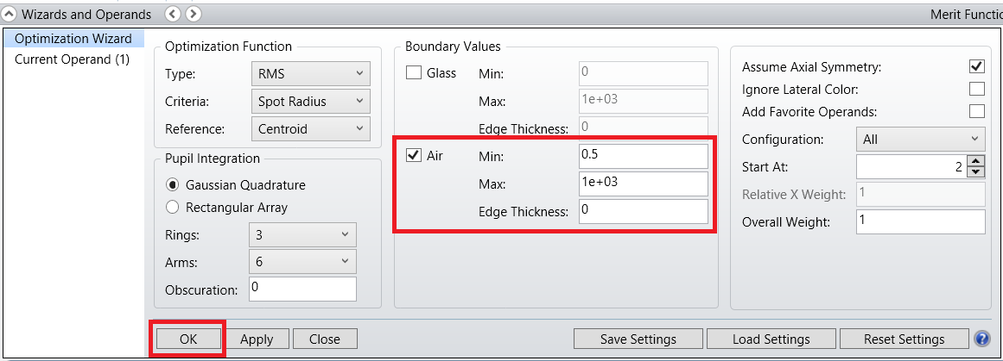

  - We get a much better design. 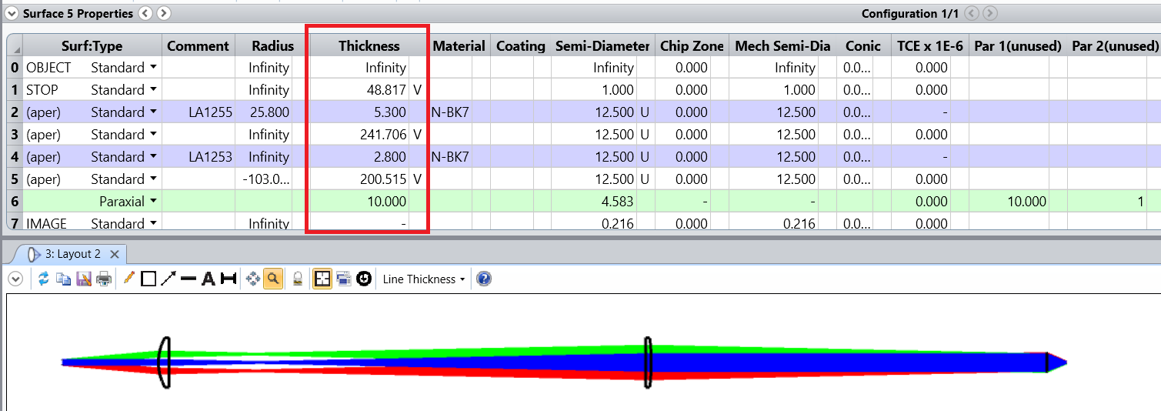

  - And the RMS spot radius is now 0.9 μm on axis, and about 0.8μm at the 5° field point.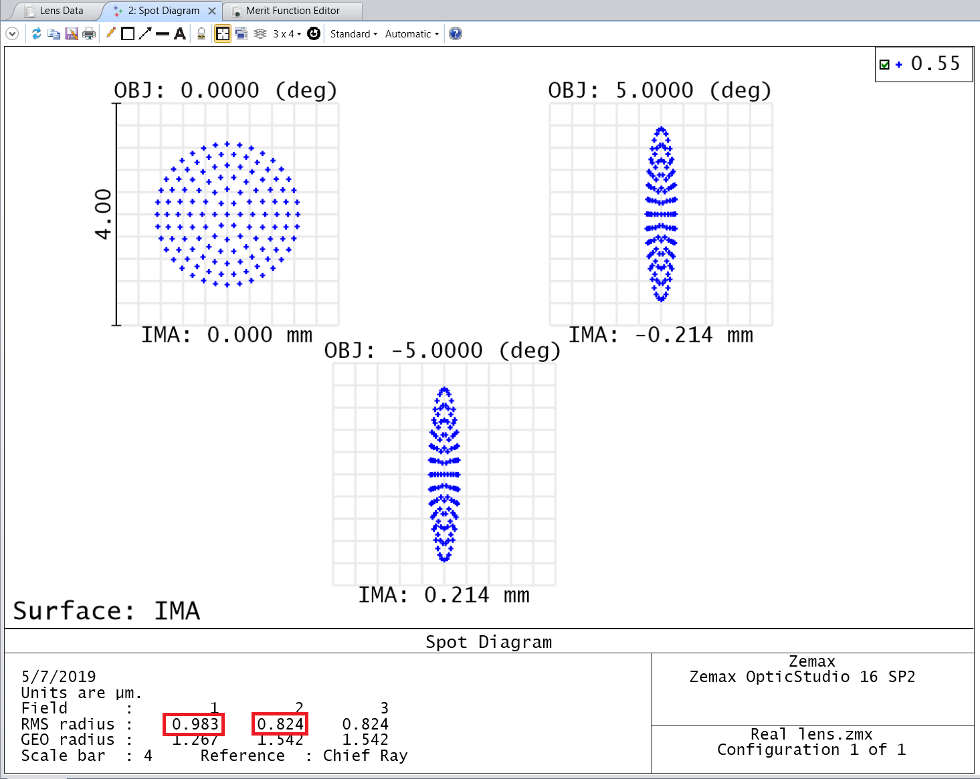

Note: The key point is that for successful optimization, the merit function should contain both the optical targets you want to achieve, plus constraints that will prevent Zemax from producing unwanted design shapes. Typical constraints include the thickness of elements, weight, maximum acceptable distortion, etc.

Reference:
Zemax, LLC Getting Started With OpticStudio 15 “https://customers.zemax.com/ZMXLLC/media/PDFLibrary/Brochures/OpticStudio_GettingStarted.pdf?ext=.pdf”

